KIDS’ EVENT
MAY 11, 2024 1 - 3PM

LET’S CREATE A SEASHORE SCENE!

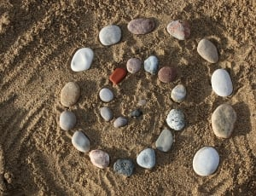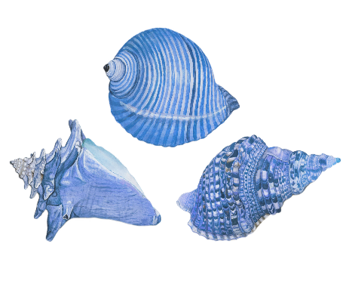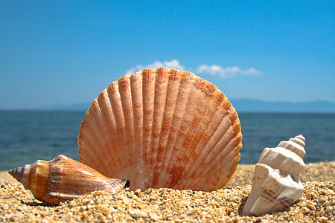

Join us for this
FREE EVENT
ALL MATERIALS SUPPLIED
(the fun stuff like glue, sand, shells!)

